New Hope Sermon Our burden-Dearing God
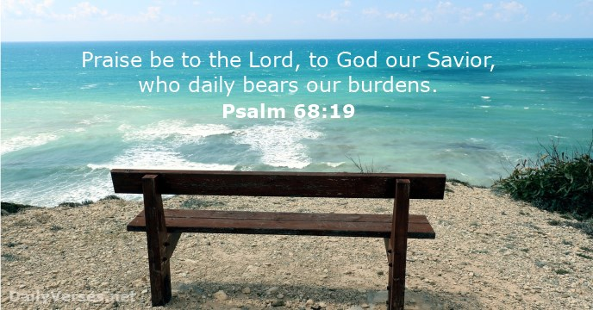
This is a very busy and stressful time for all of our students and so I want to address these issues in our sermon today on Our Burden-Bearing God. I Peter 5:7 tells us to “cast all your anxiety on him (God) for he cares for you. And Psalm 68:19 says “Praise be to the Lord, to God our Savior, who daily bears our burdens.” These are wonderful promises to claim when we are feeling the burdens of deadlines and unrelenting stress. And these stresses were certainly felt, for different reasons, by the early disciples of Jesus as well.

As we continue looking at the disciples’ walk with Jesus, in Mark 4 we come to a very familiar passage. It seems a good analogy to describe the way many feel as like the disciples did in this incident – swamped and afraid of drowning. Hear the story:
That day when evening came, he said to his disciples, “Let us go over to the other side.” ³⁶ Leaving the crowd behind, they took him along, just as he was, in the boat. There were also other boats with him. ³⁷ A furious squall came up, and the waves broke over the boat, so that it was nearly swamped. ³⁸ Jesus was in the stern, sleeping on a cushion. The disciples woke him and said to him, “Teacher, don’t you care if we drown?”
³⁹ He got up, rebuked the wind and said to the waves, “Quiet! Be still!” Then the wind died down and it was completely calm.
⁴⁰ He said to his disciples, “Why are you so afraid? Do you still have no faith?”
⁴¹ They were terrified and asked each other, “Who is this? Even the wind and the waves obey him!”

The story starts out with Jesus’ words to h is disicples, “After a long day of teaching,…‘let us go over to the other side.” Leaving the crowd behind, they took him, just as he was, in the boat. There were also other boats with him.” A regular day, a regular boat trip. But you know what happens next: “A furious squall came up and the waves broke over the boat so it was nearly swamped” – that means the water in the boat was almost parallel to the water in the lake. When a boat is swamped both the boat and the people are about to become one with the lake – the boat will go to the bottom unless it is overturned and the people in the water will know how to turn it over and unswamp it. The people will also go to the bottom is they don’t know how to swim or aren’t wearing life vets or are just too far from the shore to swim back. Learning how to unswamp a boat is a technique you teach every boater of small boats – canoes, row boats, small dingeys etc.

We had a canoe as a family when our kids were in elementary and junior high school. Our kids were both good swimmers so early on, we took them out in the canoe and taught them about swamped boats. First we had them capsize the canoe and have it fill with water. Then they had to flip the swamped boat over and with their powerful leg muscles kicking, lift the boat up over their heads and right it – without water in it! It critical because swamped boats and drowning are a major, in fact, the main cause of boating deaths. So the disciples were accurate to tell Jesus that their boat was so full of water they were all going to drown. The disciples’ fishermen’s boats were obviously bigger and heavier and could withstand these furious storms on Lake Galilee, but these were possible smaller pleasure boats just fit for Jesus and several of the disciples.

As you remember, Jesus immediately went to asleep in the stern of the boat, sleeping on a cushion. Sleeping in the midst of a furious squall when the boat must have been rather violently rocking back and forth and the men were shouting instructions to each other, was amazing. But finally the men shouted to Jesus as they woke him: ”Teacher,… don’t you care if we drown?” Those were desperate words shouted to Him in a desperate situation.

Several things to note about this famous incident. First, the power of worry. Their concerns were legitimate, for sure, but they jumped to the wrong conclusion in their fear. They ascribed indifference to Jesus – as we often do to God when circumstances seem to cascade down on us and we don’t see a way out. That’s the problem with worry. It is a sin because it calls God a liar. God promises he will supply all our needs according to His riches in glory in Christ Jesus (Phil.4:19). Worry says, ‘I don’t think God will fulfill that promise.” (Bob Russell, After 50 Years of Ministry – 7 things I’d do differently & 7 things I’d do the same, Moody Publishers, 2016, pp. 29). We quote the Bible verses and know in our head that God is sufficient, but somehow that messages does not translate down to our heart and our body – our brain is working on a different unconscious message and we come unglued. Sound about right?

“I don’t think God will fulfill that promise.” Remember the only reason the disciples were in this problem was that Jesus had told them to get into the boats and return to the other side. They were there in obedience and submission to his requests. But because they didn’t yet understand His power and sovereignty or even if he was basically good. They may have thought in their panic: Jesus hasn’t worked on the lake all his life – he doesn’t understand the weather conditions and hadn’t taken them into account!” Blame, blame, blame. In fact, he wasn’t even helping to bail the boat. “Master, don’t you care?”.....

A faith stance would be different – “Now Lord, You got me into this mess. I am here in this boat in this storm in obedience to You. You know all about storms and weather and our vulnerable state. You dot me into this. Now please get me out! I trust You to deliver me from the worst case scenario.”
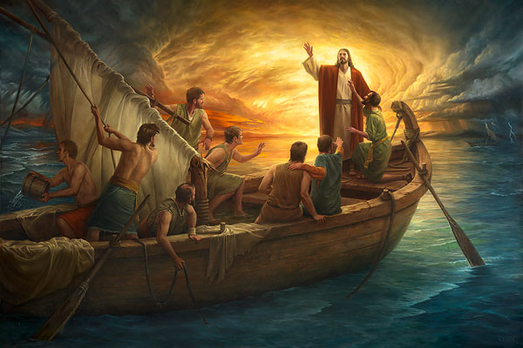
That’s idea one.

Notice, secondly, that when they woke Jesus, he immediately got up, rebuked the wind and said to the waves, “Quiet, be still! And the wind died down and it was complete calm. This flabbergasted the disciples. Who is he, they murmurer. Even the wind and the waves obey him?!” That incident displayed the divine power of Jesus and why we can trust Him in the midst of our furious squalls. He is sovereign. All nature is under His command. I’ve read two interesting applications to this fact. First, Jesus was asleep in the storm because the water was already still in his mind. He didn’t worry about un-to-ward consequences. He knew even the Father was there and could help. But he also knew his own power and could rise and address the problem head on: “Quiet be still!” and it was.

Let me pursue this still water issue a bit more. Jesus’ power over creation was so firm in his mind even as He slept that to him the water was actually already still. He didn’t worry about the storm because it was under His control. Interesting thought, isn’t it?

For us, the application is clear. We have a God who is over all the storms of life that come us and threaten to undo us. Some of those storms are related to the stress of deadlines, papers, applications etc. Some are related to health and well-being. Some are related to relationships which seem to be in trouble. But none of them are outside God’s control. Yet we feel swamped.

It seems that stress is claiming more and more of the hearts and minds of our church members this month. Our attendance at church is about half our potential and many express the deep stress they feel with all the deadlines and issues with their school work. This past week I had an unexpected hypoglycemic attack and it took was like my boat suddenly swamped. I am still recovering. Others are facing concerns over their loved ones, a mother, a grandmother back home who need medicine or hospital equipment that isn’t readily available, or who have access to hospital care but are still in pain and quite sick.. Still others are back in home country and finding restrictions from the government that is affecting jobs, church attendance, financial security etc. We are living in very stressful times and sometimes I think we want to shout out to God: “Teacher don’t you care if we drown?”

Yes, God cares and No He won’t let you drown. But we need to remind ourselves of this day by day. That’s why I want us to sing two songs right now that deal with our trust in God’s sovereignty over storms. The first is Still. The second is Press on.

I listened to the song Still by Hillsong last week when I was with Laurie. We had taken a couple of hours together while Keith was with Evan, and I went to Laurie’s house and watched her work on a watercolor painting she is doing for me. When I came home and told Evan how wonderful the song Still was, he reminded me that this is a song Sam chose and we sang last August when Sam preached. Here are the words:
Still: Find rest my soul in Christ alone
Know His power in quietness and trust.
When oceans rise and thunder roars, I will soar with You above the storm,
Father, You are king over the flood.
I will be still and know You are God.
Oh yes, Father, O yes, Father, I will be still and know you are God.
Press On: When the valley is deep, when the mountain is steep,
When the body is weary, when we stumble and fall.
When the choices are hard, when we’re battered and scarred
When we’ve spent our resources, when we’ve given our all.
In Jesus’ name we press on, In Jesus’ name we press on.
Dear Lord with the prize clear before our eyes, we find the strength to press on
In Jesus’ name we press on, In Jesus’ name we press on. Dear Lord with the prize clear before our eyes,
we find the strength to press on -(words and music: Dan Burgess)

The valleys DO seem deep to so many people right now; the mountains seem steep. The body is weary and we are stumbling and falling. The choices are hard; we feel battered and scarred. YET, IN JESUS’S NAME WE PRESS ON.

Beloved, we CAN trust God above the storm. In God’s strength we CAN press on and soar with Him above the storm. He is King over the flood. He is the One who gives us strength to go on WHEN we keep our eyes on HIM and watch His interventions bring deliverance. Nothing is too hard for the Lord. Let’s pray for one another to live this victorious faith, beloved. He will unswamp your boat. He will carry you forward. In Jesus’
Name, we press on! Hallelujah.
Dr. M.L. Codman-Wilson 11/18/18

