New Hope Global Sermon – the Spirit of Celebration

Introduction
This week our daughter was here with her husband for a week. We had a great visit and she modeled a wonderful life lesson: creating the spirit of celebration in the present moment. She called it creating memories. And she was right. So I want us to pursue this approach to life for our meditation together this week.

The importance of living in the present
From the article “A Global Pandemic and Ambiguous loss,” comes this excerpt from Pauline Boss: “Ambiguous loss is unclear, traumatic, externally caused by illness/work/leaving (not by individual pathology), confusing and incomprehensible. . . .I can’t think of a better description of the losses people are feeling during this worldwide pandemic. Quick pack-ups and overnight border closures, family separations and job losses, death with no or limited funerals, grieving alone – all of it has contributed to lack of closure and a prolonged and ambiguous grief process.

As a tool to combat the losses we have in our minds and circumstances, she advocates finding meaning in the present:
Not acknowledging ambiguous loss can cripple us to finding meaning in our present reality. What is the meaning in your present reality? Where have you found meaning that is unexpected? Perhaps you have found meaning in the act of waiting. Perhaps you have had unexpected time with aging parents. Perhaps you used to long for more time with your kids, feeling like their childhoods were on fast forward in the movie of life. Suddenly, all of life has slowed down and it feels impossible to dream, to look forward to anything. Maybe there is meaning in the impossible.”

Celebrations with Laurie and Scott In her desire to help us create new memories here in our present situation in Florida, Laurie came up with two different outings – a horse-drawn carriage ride for Valentine’s day in a special town close-by, and a ride on a swam paddle boat on Lake Eola in the center of downtown Orlando.
For these celebrations a picture is worth a thousand words:
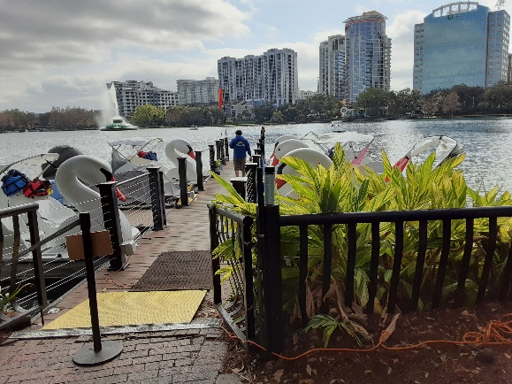
Swan paddleboat trip on a lake in downtown Orlando.
Both Laurie and Becky were the paddlers. The weather had been overcast but when we got to the lake, the sun was out and it was a lovely day. Both Laurie and Becky got quite a workout as Keith and I lounged in the back seat area and completely enjoyed the adventure with the girls and with the beauty of our setting.

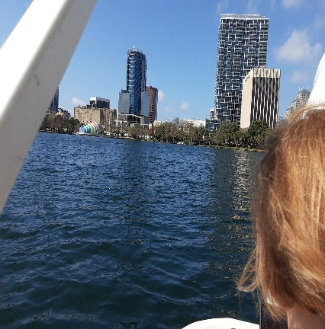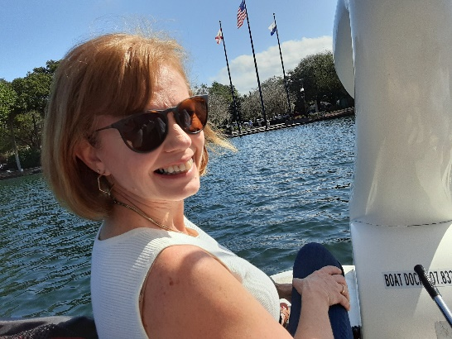

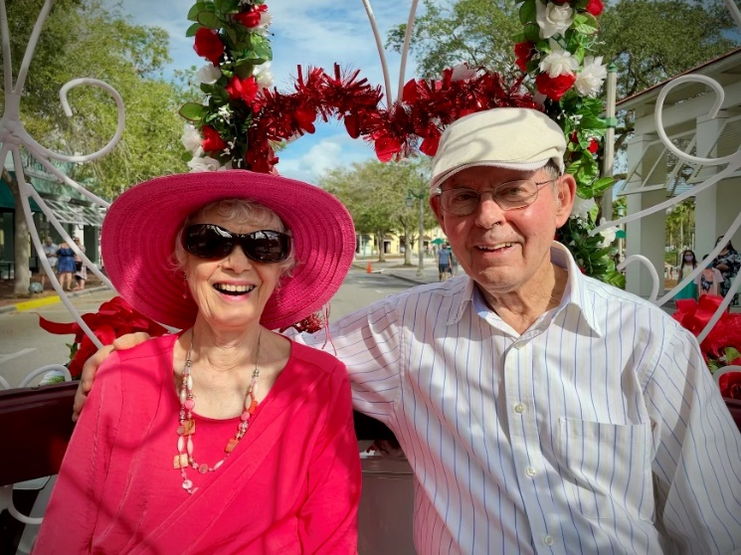
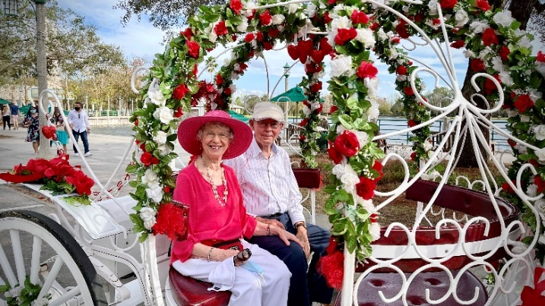

A horse-drawn carriage ride in the town of Celebration, Florida for Valentine’s day. Keith loved it and loudly announced to all the tourists we passed on the drive, “This is wonderful! You have to try this!” Then he would wave enthusiastically. People smiled in response and many people even waved back! It was surely PR beyond the driver’s expectation!
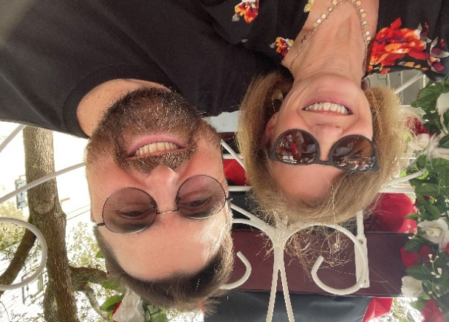

Laurie has gotten her perspective on the present directly from the Scriptures.
- Ps. 118:24 – This is the day that the Lord has made; let us rejoice and be glad in it.
- Heb.3:13 Encourage one another daily, as long as it is called Today
- Heb,10:24-25 ²⁴ Discover creative ways to encourage others^{[a]} and to motivate them toward acts of compassion, doing beautiful works as expressions of love. ²⁵ This is not the time to pull away and neglect^{[b]} meeting together, as some have formed the habit of doing, because we need each other! In fact, we should come together even more frequently, eager to encourage and urge each other onward as we anticipate that day dawning. (Passion)
- Eph. 5:18-22. And don’t get drunk with wine, which is rebellion;^{[a]} instead be filled with the fullness of the Holy Spirit.^{[b]} ¹⁹ And your hearts will overflow with a joyful song to the Lord Jehovah. Keep speaking to each other with words of Scripture, singing the Psalms with praises and spontaneous songs given by the Spirit!^{[c]} ²⁰ Always give thanks to Father God for every person^{[d]} he brings into your life in the name of our Lord Jesus Christ. ²¹ And out of your reverence for Christ be supportive of each other in love. (Passion)
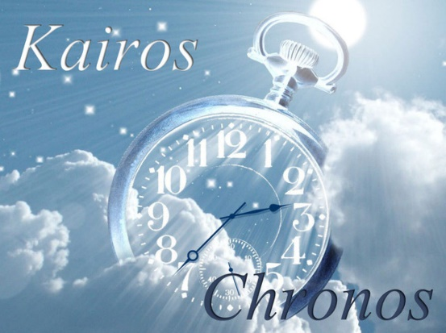
- Eph.5:16 – Redeem the time for the days are evil. Time in the scripture is both chronos, the actual hours in a day, or kairos, the God-given moments in a day. It is kairos time when we seek opportunities to create memories, to be loving, to be God’s words or presence or hands and feet in any given moment. Kairos time is when God blesses a moment, a meeting of people or an intersection of His purposes with our own schedules. Kairos time is what I learned from Laurie this past week. We can choose to make memories. And choose to buy up each moment with God’s kingdom agenda. We can choose to rejoice, to turn everything over to Him with praise and thanksgiving, to choose to think about what is loely, admirable, praiseworthy. We can choose to be all in with the Lord and share that perspective in the present moment with all those God gives us at that time. That’s how God’s blessing and peace will be with us – even in the midst of all the struggles of these days. It is a life lesson to celebrate - day after day after day. Amen.
Dr. Mary Lou Codman-Wilson, Pastor, New Hope Global Fellowship 2 20 21

