Sermon New Hope Global working as a team 6 26 22

Introduction
The beginning of Joshua 1 focuses on Joshua and his call from God, his leadership and the promises God gives to empower him to fulfill that call. That was the subject of the sermon last week. But the last 7 verses of Joshua 1, v. 10-17 are about how the Israelites as a nation were to band together as a corporate identity to fulfill God’s purposes for them as a group.

This corporate focus is very timely in 2022 because of the havoc the Covid 19 virus (and its various manifestations) have had on the practice of team cooperation. For three years the global Christian community has been isolated from in-person church and team ministries. People were in forced isolation or quarantine with their cities and nations. Churches disbanded meeting together in person; governments forbade international or even out of the city travel; students in the university were kept from the collegial repartee that comes from group learning, discussion, and exploring research and ideas together. Even children from elementary through high school had to resort to on-line classes and learning in the isolation of their homes via the internet. In fact, I read an interesting statistic about some high school students who have spent their entire high school years studying alone via zoom. As a result, they are graduating with a serious deficit in social skills. They haven’t gained the needed skills that normally accompany learning and growth through the challenge and stimulus of interdependent study and socialization.

It is time to relearn the importance of social skills and a few of the essential principles behind them.

A decade or so ago Wayne Cordeiro wrote a book called Doing Church as a Team. He highlighted several principles which contribute to successful teams in church or parachurch ministries. The one principle that is particularly relevant to the passage in Joshua 1:10-17 is called alignment. For a team to be successful each member has to be in alignment with the other members – they need to share a common vision and goal that keeps the team pulling in the same direction. Cordeiro uses the example of rowers in a racing shell. They all have to pull in the same direction, with the same amount of strength and intensity, at the same time. This is why a coxswain who steers the boat and calls out the racing rhythm for the crew so they can work in unison. Success demands that they row in alignment with one another.

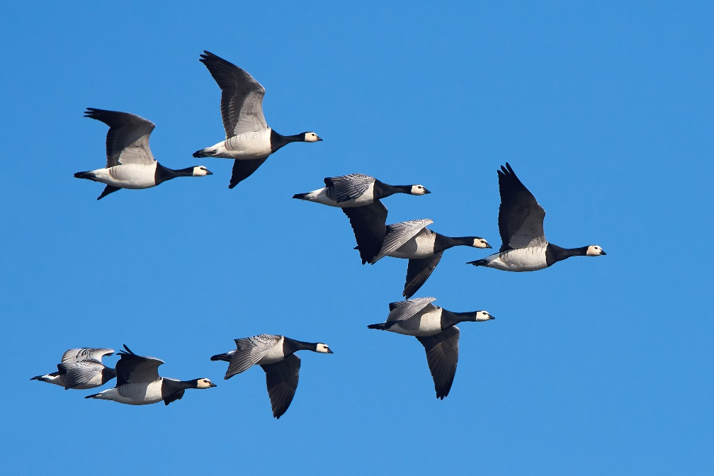
I think, however, there is an even better example of this in nature that has been revealed in a study of why geese fly in formation. I used this example in my book Of Bananas and Hard Boiled Eggs, an ESL curriculum for applied learning of language in class.

“There are five important lessons that immigrants can learn from the behavior of geese:
FACT 1. Geese fly in a V formation. As each goose flaps its wings, it helps to lift up the wings of the
birds that follow. LESSON: People who share a common direction and sense of community can get where they are going. An ESL class can become a group that helps each student become a good English language speaker. We students are all moving in the same direction.

FACT 2. When a goose falls out of formation, it loses the lifting power of the bird in front of it. It discovers the problems of flying alone and moves back into formation. LESSON: If we want to learn English, we will stay in class with those headed where we want to go and accept the help of other people.

FACT 3. The bird at the front of the formation experiences the most wind resistance. When it tires, it moves to the back of the formation and another goose takes the lead. LESSON: When we have found a job, it is good to help our coworkers succeed in their jobs.

FACT 4.Geese flying in formation honk to encourage those ahead of them to keep up their speed.
LESSON: We need to encourage people to get better jobs or our children to get better grades at school. We also need to encourage the other students in he class with us to keep using their English every day.

FACT 5. If a goose gets sick or wounded, two other geese drop out of formation and go down to the ground with it. They stay with that goose to protect it until it recovers or dies. Then they join another group of geese flying overhead to catch up with their original flock. LESSON: We need to stand by each other in difficult times until a crisis is past.” (MLCodman, Of Bananas and HardBoiled Eggs, “Lessons from Geese” Nitzia, Westbow Press, pp.30-31).

The geese honk to encourage those in the lead; the lead goose who gets tired can fall back to the end of the formation so another goose who is fresher can take the lead. This process is repeated throughout their migratory journeys and it what enables the geese to fly sometimes thousands of miles to get to their desired destinations at certain times of the year. Tin application to humans, this rotation also prevents the burnout that can happen when a team member is pulling with all his or her might but has no help when s/he gets burned out. In the goose world, the geese take care of their wounded or sick and two geese always drop out of formation to go down with the needy goose. Only after that goose recovers or dies, do they rejoin another gaggle of geese flying overhead. Too often the burned-out team member in the west will drop out of ministry alone and then must get restored and rebuild their lives on their own. That is an individual focus, and lacks the power of corporate support and relief.

How the tribes shared the work of conquering the Promised Land together
Notice in the Joshua verses how Joshua instructed the Israelites to function as a team as they were about to conquer the Promised land. Joshua 1:10-17
¹⁰ Joshua then commanded the officers of Israel, ¹¹ “Go through the camp and tell the people to get their provisions ready. In three days you will cross the Jordan River and take possession of the land the Lord your God is giving you.”
¹² Then Joshua called together the tribes of Reuben, Gad, and the half-tribe of Manasseh. He told them, ¹³ “Remember what Moses, the servant of the Lord, commanded you: ‘The Lord your God is giving you a place of rest. He has given you this land.’ ¹⁴ Your wives, children, and livestock may remain here in the land Moses assigned to you on the east side of the Jordan River. But your strong warriors, fully armed, must lead the other tribes across the Jordan to help them conquer their territory. Stay with them ¹⁵ until the Lord gives them rest, as he has given you rest, and until they, too, possess the land the Lord your God is giving them. Only then may you return and settle here on the east side of the Jordan River s in the land that Moses, the servant of the Lord, assigned to you. ¹⁶ They answered Joshua, ‘We will do whatever you command us, and we will go wherever you send us. ¹⁷ We will obey you just as we obeyed Moses. And may the Lord your God be with you as he was with Moses,’”(NLT).

First, all the people had to get ready to cross the Jordan River together. All of them were to take possession of the land the Lord their God was giving them. They were all under the corporate promise of God to their nation. Their own fears or doubts of the feasibility of this command to cross the Jordan were not entertained. They WERE to cross over – however impossible that may have seemed to many (or all?) of them. Plus, they were given a very specific time frame in which this corporate cross-over was to happen. No negotiations or conflicts or demurring were considered about why this was not a good time They were told what was going to happen, when it was going to happen, and that they would all do this together at the same time!

Second, but there is a very interesting side-bar to this general mandate for the nation. Two and one half of the tribes were allowed to stay on the east side of the Jordan and not cross over with the others. They were already in their place of rest, in the land the Lord had given them. So their “wives, children and livestock could all remain in this land Moses had assigned them on the east side of the Jordan River. But the men in each of those tribes was to cross over with the rest of the nation and fight with them to take possession of all the cities and nations on the west side. See verses 14-15: “Your strong warriors, fully armed, must lead the other tribes across the Jordan to help them conquer their territory. Stay with them ¹⁵ until the Lord gives them rest, as he has given you rest, and until they, too, possess the land the Lord your God is giving them. Only then may you return and settle here on the east side of the Jordan River.”

In many ways we have witnessed this nation-wide call to battle in the war the Ukrainians are waging with Russia. Even while millions of Ukrainians have fled to safety across the border of Ukraine to Poland and neighboring countries, the strong men were to stay back and fight for the survival of their nation. The current statistic I read this week is that 200 soldiers die daily in that valiant, gruesome fight against the Russian invaders. There are men of other nations that have crossed over into Ukraine to help in the Ukrainians’ desperate fight for freedom, so I don’t know what percentage of that 200 dying a day are actual Ukrainians, but most likely the percentage is overwhelmingly high.

It's that kind of national honor for the Israelites, under the leadership of God’s directives and power, that enabled them generally to fight as one people and take possession of one nation after another who were currently occupying the land God promised to give the Israelites. Three songs come to mind that apply these principles today.

One is Trust and Obey _ because the Israelites had to cross the Jordan River in obedience to God’s directive through Joshua -
When we walk with the Lord in the light of His Word, what a glory He sheds on our way. When we do His good will He abides with us still and with all who will trust and obey. Trust and obey for there’s no
other way to be happy in Jesus, but to trust and obey. (words: John Sammis, music: David Towner)..

The second is We are Called to be God’s people - as the 12 tribes needed to fight side by side for the good of the whole –
We are called to be God’s people, showing by our lives his grace, one in heart and one in spirit, sign of hope for all the race. Let us show how he has changed us and remade us as his own. Let us share our life together as we shall around his throne. (words Thomas Jackson, Music: Franz Joseph Haydn)

And the third is The Battle Belongs to the Lord. – because as they fought to conquer the land God promised, their certain victory was guaranteed if they followed God’s command and trusted Him to help them win the victory. And it was so.
In heavenly armor we’ll enter the land, the battle belongs to the Lord! No weapon that’s fashioned against us can stand, the battle belongs to the Lord!
We sing glory, honor, power and strength to the Lord!
We sing glory, honor, power and strength to the Lord! (words and music: Jamie Owens-Collins)

Today there are many churches, ministries, and projects that are trying to get back to their in-person calling as teams. Social skills and cooperation and interdependence need in many cases to be relearned and in all cases to be reenforced. They need to stay in alignment together with the purposes and calling God has given their specific group. And they need to encourage and care for one another within the teams that have been created to fulfill God’s call.

When we are following God’s lead, the Lord Himself will give us what we need together to bear the fruit for eternity that will bring God’s presence and hope and healing and restoration to our world. We each have a role of play – INTERDEPENDENTLY! Not just alone. May we rise to our joint calling with courage, mutual upbuilding and grateful hearts that the Lord is the One who is leading the way and providing all the grace, wisdom and social skills we need! Amen.

Dr. Mary Lou Codman-Wilson, Pastor New Hope Global Church 6 23 22

