New Hope Global sermon -Tunneling through Spiritual Crisis

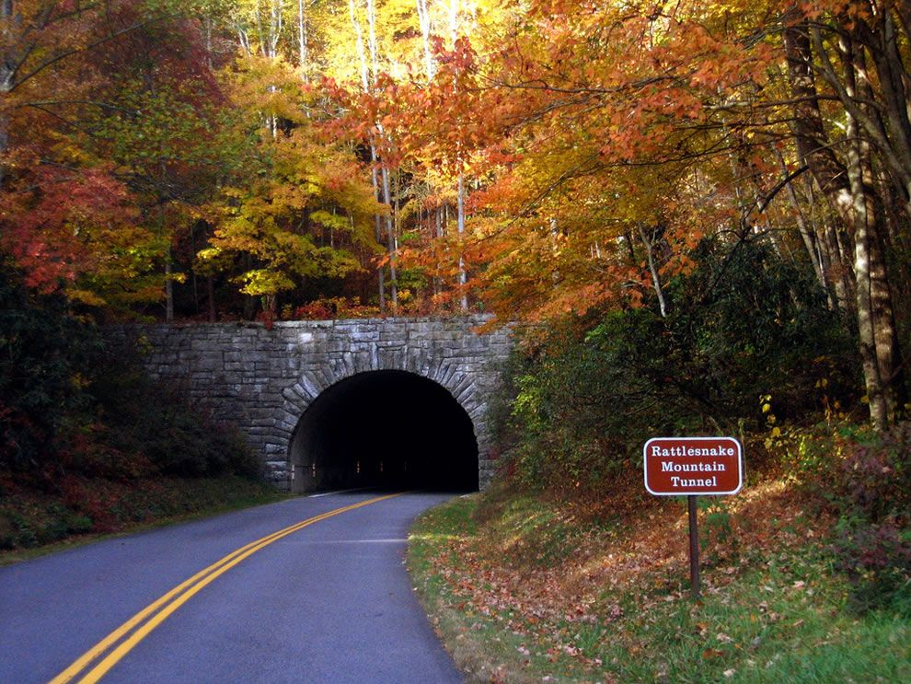
Introduction
I have never liked tunnels. The dictionary defines a tunnel as a passageway for cars and trains through a mountain or under a body of water . And that has been our experience of tunnels. In our family vacations, to get to Keith’s grandmother in Ohio from Maryland, we had to take the Pennsylvania Turnpike and several of the Allegheny mountains have been tunneled through to create that passageway. In later years as we went from Chicago to North Carolina to visit my folks, the tunnels had been created through several Tennessee mountains. So tunnels are commonplace. But they are dark; they are restrictive; if an accident happens in the tunnel, you could be stuck with all the other drivers inside the tunnel for long periods of time. The air is filled with gas fumes and if you are traveling with little children, the tunnel can seem endless. We always thanked God for safe passageway when we could see the light at the other end of the tunnel and continue our journey in the open air.

But experiencing tunnels is the subject of the sermon this week because of a phrase Mike Mason used in his book on suffering. He wrote for those who are “tunneling through spiritual crisis” (Mike Mason, The Gospel According to Job, Crossway Books, 1994, p.xi). It is such a rich analogy. Many people we know have experienced prolonged forms of suffering in these past two years. The very length of that suffering can feel like one is stuck in a tunnel – separated from God, from the light of joy and hope, from community, from the fresh breath of the Holy Spirit, unable to turn around– tunneling through spiritual crisis. How can we handle those crises redemptively? What’s at stake in our spiritual, emotional and physical lives? Those questions have double application when combined with the presence of mountains - the immovable circumstances and obstacles which also are commonplace in life’s journeys. How does one get through or around or over those obstacles? Together these two analogies provide food for thought and actual coping strategies as the fallouts from the Covid 19 virus and more commonplace difficulties of living on this planet face us in 2022.

So, join me as we think about our own confusions and anxieties in terms of tunnels and mountains. We start with mountains because sometimes God helps us remove the mountains so we don’t have to tunnel through them. But we end with how to cope with tunneling redemptively.

These Mountains Shall Be Removed
There are four main places in Scripture where mountains are symbolic of troubles affecting God’s people. In all of these instances God is the One who overcomes or helps His people overcome the obstacles the mountain poses.

1.In Jeremiah 51:25 God compares the Babylonian kingdom, which had captured and enslaved Israel for decades, as a “destroying mountain.” As the Israelites lamented in v. 14: “King Nebuchadnezzar^{[a]} of Babylon has eaten and crushed us and drained us of strength. He has swallowed us like a great monster and filled his belly with our riches. He has thrown us out of our own country.” That, in microcosm, explains the depth of suffering the Israelites faced at Nebuchadnezzar’s hand. But God had a word for this “mountain” of power and destruction:
“Look, O mighty mountain, destroyer of the earth! I am your enemy,” says the Lord. “I will raise my fist against you, to knock you down from the heights. When I am finished, you will be nothing but a heap of burnt rubble. ²⁶ You will be desolate forever. Even your stones will never again be used for building. You will be completely wiped out,” says the Lord. (Jeremiah 51: 25-26 NLT)
When God demolishes a mountain, it is demolished indeed – no need to tunnel through; just exult in your deliverance from its power.
2. Zechariah was a prophet centuries after Job, but he became God’s voice saying that King Zerubbabel could overcome the mountains he faced. Zerubbabel and Zechariah’s context was that the Jews had just recently returned to Jerusalem from their captivity in Babylon and faced a city and its temple in ruins. Here is how God speaks to that problem:
⁶ Then he said to me [Zechariah], “This is what the Lord says to Zerubbabel: It is not by force nor by strength, but by my Spirit, says the Lord of Heaven’s Armies. ⁷ Nothing, not even a mighty mountain, will stand in Zerubbabel’s way; it will become a level plain before him! And when Zerubbabel sets the final stone of the Temple in place, the people will shout: ‘May God bless it! May God bless it!’^{[a]}”
⁸ Then another message came to me from the Lord: ⁹ “Zerubbabel is the one who laid the foundation of this Temple, and he will complete it. Then you will know that the Lord of Heaven’s Armies has sent me. ¹⁰ Do not despise these small beginnings, for the Lord rejoices to see the work begin, to see the plumb line in Zerubbabel’s hand.” (Zech. 4: 6-10 NLT)

Zerubbabel’s mountain was the mountain of rubble (4:7) that had to be cleared for the laying of the foundation and rebuilding of the temple. Zerubbabel also faced derision from those less than enthusiastic about the project. (4:10). Some remembered the grandeur of the former temple and felt this new temple would only be a shadow of that grandeur. “But in both cases the prophet promises a reversal. The great mountain will become “level ground” and despising will become ”rejoicing.” (Mark Boda, NIV Application Commentary, Haggai and Zechariah, Zondervan, 204, p.p. 276, 278).

I took the title for this section of the sermon from the wonderful choral anthem that is based on v. 6 of this passage. I have sung it many times over the years and hope it will encourage you as well:
Not by might, not by power, but by my Spirit says the Lord. 2x
These mountains shall be removed. I’ll build my kingdom through you And what I’ve promised
shall be done, for it’s not by might, not by power, but by my Spirit says the Lord.
(words and music: Leslie Phillips)

Mountains come in many forms, literal and figurative. The mountain of rubble Zerubbabel faced was literal, but it was also symbolic of the ruination of Jerusalem and the discouragement of the people as they had to start rebuilding. Yet, God promises these hindrances can be removed by the Spirit. God Himself would make possible what humanly Zerubbabel could not accomplish.

3. Gospel writer Luke says John the Baptist fulfilled an Isaiah passage on the leveling of mountains:

It was now the fifteenth year of the reign of Tiberius, the Roman emperor. . . At this time a message from God came to John son of Zechariah, who was living in the wilderness. ³ Then John went from place to place on both sides of the Jordan River, preaching that people should be baptized to show that they had repented of their sins and turned to God to be forgiven. ⁴ Isaiah had spoken of John when he said, “He is a voice shouting in the wilderness, ‘Prepare the way for the Lord’s coming! Clear the road for him! ⁵ The valleys will be filled, and the mountains and hills made level. The curves will be straightened, and the rough places made smooth. ⁶ And then all people will see the salvation sent from God.’”^{[c]} (Luke 3:1,3-6, NLT).

John’s message of repentance and forgiveness was to prepare people for Jesus’ coming as the Messiah. The mountains of their doubt and sinfulness had to be leveled before the Lord’s glory could be revealed to them. So this time the mountains were leveled both by the Spirit and John’s dynamic preaching.

4. And finally, Jesus himself spoke of casting out the mountains of doubt and unbelief in the incident when his disciples could not heal a demon-possessed boy. Peter, James and John had just seen Jesus transfigured but when they came down that literal mountain experience of glory, they faced a different mountain.
¹⁴ At the foot of the mountain, a large crowd was waiting for them. A man came and knelt before Jesus
and said, ¹⁵ “Lord, have mercy on my son. He has seizures and suffers terribly. He often falls into the fire or into the water. ¹⁶ So I brought him to your disciples, but they couldn’t heal him.”
¹⁷ Jesus said, “You faithless and corrupt people! How long must I be with you? How long must I put up with you? Bring the boy here to me.” ¹⁸ Then Jesus rebuked the demon in the boy, and it left him. From that moment the boy was well. ¹⁹ Afterward the disciples asked Jesus privately, “Why couldn’t we cast out that demon?” ²⁰ “You don’t have enough faith,” Jesus told them. “I tell you the truth, if you had faith even as small as a mustard seed, you could say to this mountain, ‘Move from here to there,’ and it would move. Nothing would be impossible.^{[a]}” (Mt. 17:14-21 NLT)

God can empower us through our faith and obedience to the Spirit to overcome our mountains. He can remove them altogether; or we can go over them, take them apart piece by piece and thus conquer them.

OR, we can learn how to tunnel through them.

Tunneling through our mountains.
In getting to the stage where we have to tunnel through our mountains because God has not answered our prayers yet to remove them, there are several considerations we must internalize. Here are two pieces of advice from Mike Mason’s book. Both have to do with our mental approach to the tunneling situation:
Why should we expect life to be reasonable? It is the Lord who is sovereign, not human reason. While faith is not contrary to reason, it does greatly surpass it. The Spirit must control the mind, not the other way around…If Jesus Christ is our Lord, we must allow Him not only to inform our thinking, but to override it. If we are never prepared to take a step without a clear understanding of where we are going, and if we have no experience of folding the wings of the intellect and of doing things for no other reason than that the voice of God is speaking to our hearts, then as much as we may think we know the Lord, we’re still hanging back from what it means to be known by Him” (Mason, the Gospel According to Job. Ibid, p. 424).

“The point is not how big or how little the problem is, the point is. . .whether one’s own particular burden is being borne in the bitterness and pride of the flesh or in the grace of God” (Mason, Ibid.,p. 34)

This mental overriding by Jesus is key. In the tunnel one experiences disappointed expectations, a sense of frustration or discouragement at the length of time in the darkness, a feeling of hopelessness in not being able to reverse our situation, and a great need for the fresh air of the Spirit amid the stale air of fumes generated by others in our dark situation. We long for the light and hope of getting through the tunnel. But if we remain fixated on the struggles and mental, emotional or physical suffering we are experiencing, we will stay stuck in negativity. We need to focus on the Lord and his great and precious promises, and forcibly bring our mind and heart under the control of the Holy Spirit, so we not only live by the Spirit, we walk by the Spirit. (Gal. 5:25).

Mason gives this telling explanation for why Job’s three friends were so ineffective in their consolation for Job. He says:
They are ‘worthless physicians,” (13:4) and miserable comforters” (16:2) because their would-be consolation is really condescension. Instead of working to discover their friends’ sin they should have worked at disclosing his saintliness. They should have let go of being saints themselves and concentrated instead on being plain old sinners. Then they might have told Job about the never-failing love of God and they themselves might have embodied that love for him. But they missed their chance.” (Mason, Ibid, p,.242).

Summary:
The Bible speaks to the hindrances mountains pose in our faith journey. And how God answers with the power to remove those mountains through our faith and obedience in following the Spirit. But the Bible also speaks to those of us who have not yet experienced the removal or transformation of our mountains. As we tunnel through them in our spiritual crises, God is clearly trying to transform us and shift our focus from the problems to His unfailing love and great and precious promises. It is seeking to override our minds and provide his sustaining power, presence and perseverance so we can deal with our struggles and sufferings redemptively for his glory. Then, even in the tunnel we can sing:
When I am down and O my soul, so weary, when troubles come and my heart burdened be,
Then I am still and wait here in the silence until you come and sit awhile with me.
You raise me up so I can walk on mountains. You raise me up to walk on stormy seas.
I am strong when I am on your shoulders. You raise me up to be more than I can be.
(Lyricist Brendan Graham. Music video Josh Groben)

Let’s pray for one another that we can lay hold of our eternal perspective and sing of God’s deliverance even as we wait in hope for the light that WILL come at the end of our tunnels. He WILL raise us up to walk on the very mountains that have hindered us. Hallelujah! Amen.
Dr. Mary Lou Codman-Wilson, Pastor New Hope Global Fellowship November 3, 2021

