New Hope Global Sermon – 11 16 21 God Led Them Safely (Ps. 58:57)

Introduction
Covid-19 has certainly upended the life of almost every person on the planet. So the promise that God can guide us safely is huge. In this upside-down world today the straight places have become crooked, the smooth places have become rough, the mountains rise up to block our path and the valleys of depression and turmoil threaten the well-being of the soul. So, we need to be reminded of God’s over-arching sovereignty and goodness. Just as God did for the Israelites in Bible times, so God can do today – He can lead us safely.

Learning how to recognize God’s signs in guidance may feel like putting together a jigsaw puzzle.
Confession: Sometimes piercing together a puzzle loses its sense of adventure and enjoyment for me and has become more frustrating than fun. What should have been done fairly quickly has taken much longer because of the problems in finding pieces that fit together. I think this can happen as well in our efforts to make sense of God’s leading. There can be frustration; the time lapse can be difficult, and a sense of inner darkness hovers over us instead of the light of the Lord.

So, to help us persevere and grow in our faith, as we wait for God to lead us where we need or hope to go, here are a few tips.

Look for the Patterns
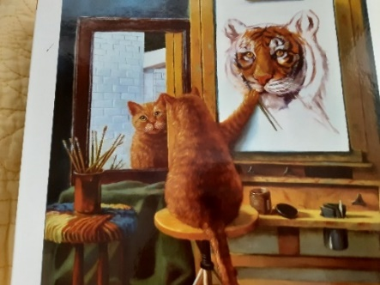
Almost exactly a year ago (10/28/20) I preached a sermon called “Look for the Patterns.” It was based on an analogy of working to complete a jigsaw puzzle. The literal puzzle itself was of a cat looking in the mirror and seeing himself as a tiger. Our self-understanding, i.e., our value and how we feel we fit into God’s purposes, was the first principle of application. But the guidance part came in how to assemble all the disparate pieces of the puzzle. And that’s the application we are pursuing today. Let me refresh our memory about this with a few paragraphs from that sermon. I believe they will help those of us who are trying to make sense of God’s purposes and wanting to hold on to the truth that God can lead us safely to the place and purpose He has for us:
“Second, the frame. Jigsaw lovers know the importance of starting a new puzzle by connecting each outside piece that makes the frame. With the frame in place, then the pieces can be connected from the outside to the inside. The frame symbolizes the outer parts of our life that are unique to each of us - our heritage, our personality, our body, our gifts, natural and spiritual, all the basic components of us God works with. Sometimes, we rail at God for these things: the dysfunction of our family system, a weak body with various susceptibilities, sometimes our gender or even our race. But all these things situate us in a certain time and place in history. They are the boundary lines – the frame – God has given us.

In Psalm 16 David says to God, “The boundary lines have fallen for me in pleasant places. My heritage is beautiful to me.” Yet, later, after he was anointed king while Saul was still the King of Israel, Saul became insanely jealous of David and repeatedly sought to kill him. David had times of desperation and grief and inner turmoil. But despite that, he held onto the truth that he was who God created him to be and so he turned his focus back to God’s love and sovereignty and goodness: “I will praise the Lord, who counsels me; even at night my heart instructs me.
I have set the Lord always before me, because he is at my right hand, I will not be shaken.
Therefore my heart is glad and my tongue rejoices; my body also will rest secure.” Even when
all around him seemed to spell disaster, “David encouraged himself in the Lord his God.”(I
Sam.30:6)

Third, in putting together a jigsaw puzzle, it is the patterns that give us clues about the whole picture. In our literal puzzle there are colors that clearly go together and literal lines that we can connect. There are images, like the cat and the tiger, that are recognizable enough to be fitted together. Each coordinating section gives coherence to one part of the puzzle and then another.

Similarly, I believe there are patterns we need to discern in our own lives – a time when a loving community was around us, a time when God’s call was clear, when we received words of hope and direction from others, when openings happened where we thought the pathway was blocked. As we recognize those connection points, then we can begin to make sense of the whole. The Spirit can help us find those patterns if we ask. God wants to give discernment or revelation or even faith to see and welcome His footprints on the sand of our lives.” (“Look for the Patterns,” Dr. ML Codman-Wilson, New Hope Global Sermon, 10/28/20).

So, acknowledging God’s hand in this incredibly unstable time in our lives, we need to trust God to work within the frame, the boundary lines, God has already established for us. Then in faith we go step by step, discovering the patterns as each piece fits with another – even while the whole picture seems maddingly incomplete. God has the whole picture in mind, so when we follow the Spirit’s leading, we will reach God’s purpose. And be able to praise Him that He has led us safely.

Think and Act Corporately
But often jigsaw puzzles are put together by an individual. In seeking to understand how God leads us through this upside down time of uncertainty, we need to think corporately. We need to face the struggles of the soul - the dimness of our soul, our weakness, “the rising doubt, the rebel sigh, . . unanswered prayer” (“Spirit of God descend upon my heart,” words by George Croly). And, walk beside those who are temporarily paralyzed by these struggles.
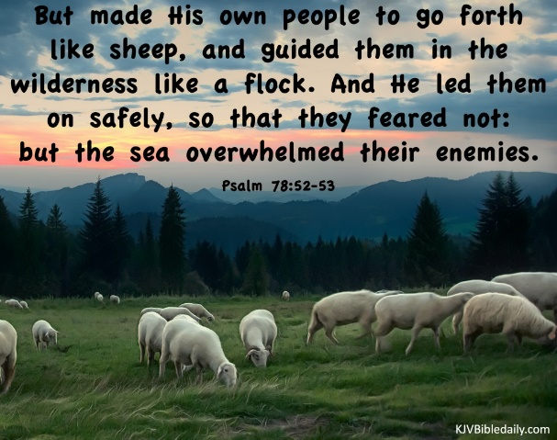
It is helpful when we chose together to focus on God’s promises encapsulated in our theme text for today: “He guided them safely” (Ps. 78:53). The context is a reference to God’s leading the Israelites out of Egypt, through the desert and across the Red Sea. Then came God’s promise to bring them into the promised land: “See, I am sending an angel ahead of you to guide you along the way and to bring you to the place I have prepared” (Ex. 23:20).

The Israelites’ pathway to that place was neither straight nor smooth but God was the One who cleared the way as Israel slowly took possession of all the nations that were living in the land God promised to give them (Exod. 23:20-33). When the
Israelites followed God’s directions, He did bring them to the place He prepared. But, when they
rebelled and tried to conquer the promised land in their own strength, they were defeated. As Isaiah the prophet reminded them: “It was not by their sword that they won the land, nor did their arm bring them victory; it was your right hand, your arm, and the light of your face, for you loved them. . . This is how you guided your people to make for yourself a glorious name” (Ps. 44:3, Isa. 63:14).

This eternal purpose of God still applies to what God will do in our time of history, beloved. We can
trust Him to give us directions step by step as we put together the puzzle pieces of His guidance. We will receive His strength and renew our hope when we remember God’s ultimate objective – that through our tested faith, His name will receive the glory. That’s because as He brings us through to the place He has prepared for us, it will be clear that this was the hand of God at work, not our own plans.

I actually have the year 2015 marked beside this title passage in my Daily Light for November 11. It was in reference to God’s confirmation of the internationals’ request that we move our house church from the country in Carol Stream into Wheaton by the college campus that year. The international members of New Hope felt if our church was within walking distance from the campus, many more internationals would come. And they were right. The house itself had some major and costly problems structurally, (the path for us was not straight nor smooth either), but we saw the glory of the Lord revealed over the following five years as the church community grew in faith and openness and deep caring for one another. Those bonds and deep ministry connections continue today. And living in our 911 Washington St. house provided the most fruitful and satisfying years of our entire lives of ministry together for Keith and I.

Then and now the song “Press On” by Selah captures the spirit we need as we go forward under God’s new direction:
Though the valleys are deep, though the mountains are steep, though the body is weary,
though we stumble and fall; when the choices are hard, when we’re battered and scarred, when we’ve spent our resources, when we’ve given our all:
Refrain: in Jesus’ name we press on. in Jesus’ name we press on. Dear Lord with the prize clear before our eyes, we find the strength to press on. 2 x To press on. (“Press on, “Selah, 2011).

With the unknowns and uncertainties looming ahead of us in 2022, let us continue to press on together, praying for one another, providing direction and encouragement for one another, and keeping the good purposes of the Lord continually before us. The Lord is the One who will guide us safely- all because of His boundless love and mercy. Thanks be to God! Amen.

Dr. M.L Codman-Wilson, Pastor, New Hope Global Fellowship, 11 16, 2012

