New hope sermon - Established!

Introduction
The Lord brought a strong word to me today as I was praying over each member of our community and family. It is the word establish. The dictionary definition means “to make firm, make stable, settle, to set up a nation, a business, a place, to order or ordain.” There is a sense of permanence and settledness in being established. And when God is the One who promises to establish us, there is the future and the hope He has promised.(Jer. 29:11)
In fact, the context of that Jeremiah promise shows how God establishes His people after a season of distress:
¹⁰ This is what the Lord says: “You will be in Babylon for seventy years. But then I will come and do for you all the good things I have promised, and I will bring you home again. ¹¹ For I know the plans I have for you,” says the Lord. “They are plans for good and not for disaster, to give you a future and a hope. ¹² In those days when you pray, I will listen. ¹³ If you look for me wholeheartedly, you will find me. ¹⁴ I will be found by you,” says the Lord. “I will end your captivity and restore your fortunes. I will gather you out of the nations where I sent you and will bring you home again.” NLT
Although the Jews’ captivity and whatever is the cause of our present situation distress is under God’s control and providence, the promise of restoration, of being established by the Lord, is a source of hope and joy.

Here is how the word “establish” came for many of our community and family members.

God promises to establish His followers
Two promises particularly came to mind in terms of God’s promise to establish His followers – one in Ps. 40, and the other in Ps. 90:
Ps. 40 – I originally memorized these verses in the King James decades ago. It says: “I waited patiently for the Lord; And He inclined to me And heard my cry. ² He also brought me up out of a horrible pit, Out of the miry clay, And set my feet upon a rock, And established my steps. ³ He has put a new song in my mouth—Praise to our God; Many will see it and fear, And will trust in the Lord.
NRSV says: He set my feet upon a rock, making my steps secure.
Passion says: He stooped down to lift me out . . .from the desolate pit I was in, . . . Now he’s lifted me up into a firm, secure place and steadied me while I walk along his ascending path. ³ A new song for a new day rises up in me every time I think about how he breaks through for me!
God established my steps…secure steps and a secure place, steadied me.
This is the same sense that is in Ps. 90:17: May the favor^{[a]} of the Lord our God rest on us; establish the work of our hands for us—yes, establish the work of our hands. NIV

God is the One who establishes us in a secure place – our location. He establishes our steps – our direction that will get us there. He establishes the work of our hands – our ministry in serving others.

And it is this whole package in which His word of establishing us came in prayer.

God’s Word made personal
So here is how these words guiding my prayers for my family and our community. First, thinking of my blood family: Our grandson Sam is starting his first year as an art teacher in a Christian school near Naples Florida and needs establishment in that career
- Our granddaughter Audrey is starting the new school year as a returning teaching having just birthed her first baby. God establishing her will keep her life steady and balanced both as a teacher and a mother. .

Then in our community:
- Given is in the same position as Sam – starting his first year as a teacher (for him of chemistry) in a Christian school in Orlando
- Our new international students at Wheaton Grad have arrived from Indonesia, Kenya, Nepal, Colombia, and other far flung countries. They need God’s establishment in wisdom, grace and cross-cultural savvy as students in a new academic year, in a new country, with new academic expectations and teaching methods. (We have met a few – Christina from Indonesia with her husband Nico, Rebecca from Kenya, Madhu from India, Lilianna from Colombia. ) Our hope is to come alongside some of them as a family for them in this new setting. Also, in our live-in household, Ruth from China is beginning as a new PhD student in Counseling at Wheaton.

Then we have all those who hope to graduate in 2022 and be established in God’s future path: Hanny, Emmie, our son Bruce, his son Graham. For each of them we ask that the crooked places be made straight and God brings all that is needed (including justice for our internationals in their programs) so they can finish well.

And we have Alex waiting to see where he will be accepted and established as a career faculty member of a law school - he has applied to 2 top universities in Singapore, and one in HongKong.

We have Miyuki and Dionisio waiting to get their green card or R1 visa to work legally in the States and be established in their ministries here.

And we have Grete and Keith and I in our geographic moves: that Grete would get established in her ministry to internationals in Newport Rhode Island (God has provided a new house for her but she has covid and needs God’s healing so people can come into her house and help her with the move and she can reach out in ministry). We feel a great sense of being home and belonging here in Wheaton again. We have finally gotten a reliable caregiver (who is the son of parents I have known for years. Abraham and his brothers even were part of our house church out in Rolling Oaks.) But now we are in a new era of life here and seeking to rebuild community, get established in a new neighborhood and established in a new international student outreach which we have named IGGF – International Grad Garage Fellowship! (see brochure).
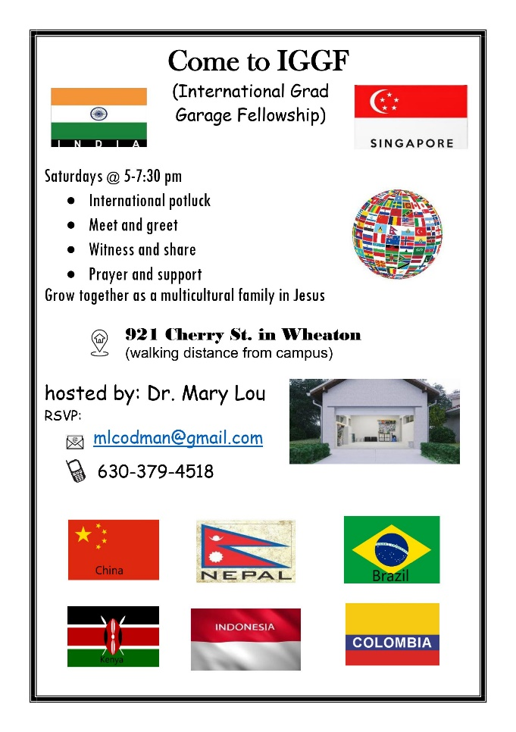
This is an offshoot of our house church, New Hope Bible Fellowship. We are looking forward to how God can establish this new ministry among internationals. We start this coming Saturday, CST 5-7:30pm. As at the house church, we will begin with an international potluck. I have been cooking and I look forward to the meals that other internationals will bring. Starting in a garage is quite different than being in our 911 Washington Street house, but this is what God has made available and so now we trust Him to “establish the work of our hands”.

Blessings,
Dr. Mary Lou
09/01/21

