New Hope Global Sermon Resurrection Energy 5 20 22

Introduction
In the book of Hebrews the author tells his readership not to lose heart, not to grow weary, and not to despair over God’s discipline of them or because of the struggles they were facing in persecution and hardship. (Heb. 12). God is in control and He will bring them through.

In fact, in New Testament times most of the churches Paul and his team planted suffered persecution. Paul himself paid a dear price as the pioneer of the good news to the Gentiles. He tells the Corinthians he was “harassed at every turn – conflicts on the outside, and fears within” - which caused him to be “downcast” (2 Cor.7:5-6.) Then in chapter 11 of that same letter he lists the sufferings he endured for the gospel –
⁴ Five times I received at the hands of the Jews the forty lashes less one. ²⁵ Three times I was beaten with rods. Once I was stoned. Three times I was shipwrecked; a night and a day I was adrift at sea; ²⁶ on frequent journeys, in danger from rivers, danger from robbers, danger from my own people, danger from Gentiles, danger in the city, danger in the wilderness, danger at sea, danger from false brothers; ²⁷ in toil and hardship, through many a sleepless night, in hunger and thirst, often without food,^{[a]} in cold and exposure. ²⁸ And, apart from other things, there is the daily pressure on me of my anxiety for all the churches. ESV 2 Cor.11:24-28.

Still, in those contexts, Paul speaks repeatedly of how God’s grace made him strong to fulfill God’s calling on his life which he explained to the Colossians as ^{8 “}Christ we proclaim, warning everyone and teaching everyone with all wisdom, that we may present everyone mature in Christ. ²⁹ For this I toil, struggling with all his energy that he powerfully works within me.”

It is the phrase ”struggling with all his energy that he powerfully works within me” that caught my attention. I thought of the many Christians today who have experienced weariness, downcast spirits, anxieties and fears these past couple of years, and how this can cause us to look at life negatively as a cup half empty. I also recognize that in these times even when we acknowledge God’s love and sovereignty, what we know in our minds often takes the work of the Spirit to move down into the areas of the emotions. God has created humans with a complex interweaving of our emotions, our hearts, our minds and our bodies. Long-term negative struggles can create a negative mindset. We have seen that clearly in the last couple of years with the Covid pandemic and what the resulting loneliness, isolation, fear and anxiety has caused in people’s psychological well-being. Certainly, our accumulating daily stress because of Keith’s debilitating Alzheimers has taken a big toll on both Keith and I.

Paul faced his own set of crushing negatives in his ministry and yet he continued faithful to his call because he experienced Christ’s resurrection energy. That needs to be our story as well. So, I wanted to explore this issue together. Resurrection energy gives empowerment and hope. It becomes the source of our resilience and sustaining faith. And it is this energy that God wants to “powerfully work within us.” How can we live in these truths?

Put Up Your Umbrella of Grace
Let me start with a simple illustration from Tony Evans:
“If it is raining outside, you may want it to stop, but you can’t control the rain. However, you can open an umbrella. An umbrella does not change the circumstances, but it changes you in the middle of the circumstances. The wetness is no longer controlling you.
God’s grace opens up an umbrella during the rainy seasons of life so that we may overcome and have the victory even when everything around us is wet.” (Tony Evans’ Book of Illustrations, Moody, Press, 2009, p. 215).

Paul obviously kept God’s umbrella of grace open during his seasons of stormy circumstances, persecution, dangers in the churches and his own “thorn in the flesh” (2 Cor. 12). And he encourages all the new converts in the faith to do the same. Here are four ways to live consistently in Christ’s resurrection energy:

First, believe it!
The truth is that the same power that raised Christ from the dead dwells IN every Christian believer. Christ’s resurrection was not only for his sake, but now makes that kind of life available to all His followers. This is an astounding truth and one we need to claim and act on in our daily lives.

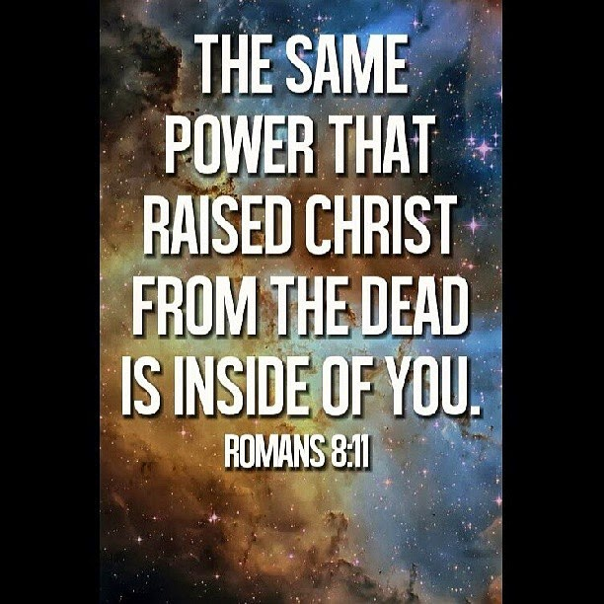
Second, pray about it!
In Ephesians 1:16-19 Paul prays that the Ephesians ¹⁶ experience “God’s spiritual wisdom^{[a]} and insight so that you might grow in your knowledge of God. ¹⁸ I pray that your hearts will be flooded with light so that you can understand the confident hope he has given to those he called—his holy people who are his rich and glorious inheritance.^{[b]19} I also pray that you will understand the incredible greatness of God’s power for us who believe him. This is the same mighty power ²⁰ that raised Christ from the dead and seated him in the place of honor at God’s right hand in the heavenly realms.” NLT So, when we are in a turbulent rain storm, that may seem like a monsoon season, we need to pray for ourselves and also call out for others to pray for us. This has been lifesaving to me over these Alzheimer years with Keith.

Third, resist Satan’s lies!
Jesus said Satan is always trying to steal, kill and destroy Christians and every attempt they make to forward God’s kingdom agenda (Jn.10:10). Satan and his evil armies are the ones who put voices in our heads that we can’t do what God has called us to, voices that focus our energy and attention on the negatives, voices that take our eyes off of Jesus and onto the problems, voices that catastrophize negatives into the future, etc. These voices will depress, distract, discourage, and defeat us unless we resist them as an act of faith. Remember when Peter had stepped over the keel of the boat to walk on water toward Jesus? He had acted in faith and Jesus had enabled him to do it, until he took his eyes off Jesus and looked at the wind and waves swirling around him. That’s when he started to sink!

So, as Paul advocates in Ephesians 6, we must daily put on the helmet of salvation and say no to these voices in our head; we put on the shield of faith which will quench all these flaming darts of the evil one; we put on the belt buckle of truth and attach the sword of the Spirit, so we can counter Satan’s distortions with the Word of God (like Jesus did in his temptation episode with Satan recorded in Luke 4). All this we must literally do every day in faith. The R+R of victory over evil are Resist and Rebuke. Hear these wise words:
“The only way we can be sure that satan knows we are resisting him is to speak aloud, to directly and audibly confront him with the truth. . . Our resistance by itself is not what causes Satan to flee; he flees because of the power of Jesus which is ours through prayer. . .With our authority comes the responsibility to use it for God’s purposes. If we don’t rebuke the devil, he will not be rebuked. If we don’t drive him back, he will not leave. It is up to us. Satan knows of our authority, but hopes we will stay ignorant” (“The Name of Jesus, Quin Sherrer and Ruthanne Garlock, Breakfast for the Soul, ed. Judith Couchman, Honor Books, pp.100-101)
Revelation 12:11 says: “We overcome Satan by the blood of the Lamb and by the word of our testimony”

And fourth, sing it out in faith!
There is a tremendous power in praise as it lifts up our victorious God, acknowledges Satan’s defeat and clears our minds and hearts to live in Christ’s resurrection energy. Psalm 106:47 says: “Save us, O Lord our God, And gather us from among the Gentiles, To give thanks to Your holy name, To triumph in Your praise. “ We sound God’s triumph and ours through praise.

Here are four songs on this theme: First, a resurrection song which seals this triumph:
Christ the Lord is Risen today
v. 1. Christ the Lord is risen today, alleluia. All creation join to say alleluia. Raise your joys and triumphs high alleluia. Sing ye heavens and earth reply alleluia. V.4 Soar we now where Christ has led. Alleluia . Following our exalted Head. Alleluia. Made like Him, like Him we rise. Alleluia. Ours the cross, the grave, the skies. Alleluia.

– Second, Reuben Morgan’s Still: “Hide me now under Your wings. Cover me within Your mighty Hand. Chorus: When the oceans rise and thunders roar, I will soar with You above the storm. Father, You are King over the flood. I will be still and know You are God.
Rest my soul in Christ alone. Know His power in quietness and trust. When the oceans rise and thunders roar, I will soar with You above the storm. Father, You are King over the flood. I will be still and know You are God.”

-Third, Martin Luther’s A Mighty Fortress. Verse2-3 “Did we in our own strength confide, our striving would be losing. Were not the right man on our side, the man of God’s own choosing. Doest ask who that may be? Christ Jesus, it is he: Lord Sabaoth is his name, from age to age the same, and he must win the battle. And though this world with devils filled should threaten to undo us. We will not fear for God hath willed his truth to triumph through us. The Prince of Darkness grim, we tremble not for him. His rage we can endure, for lo his doom is sure. One little word shall fell him.” [That word is the name of Jesus!]

-And, finally, Charles Wesley’s Soldiers of Christ Arise. “Soldiers of Christ arise and put your armor on, strong in the strength which God supplies through his eternal Son. Strong in the Lord of hosts, and in his mighty power, who in the name of Jesus trusts is more than conqueror. 2. Stand then in his great might, with all his strength endued, and take, to arm you for the fight, the weapons of our God; from strength to strength go on, wrestle and fight and pray; tread all the powers of darkness down and win the well-fought day.”

Living in terms of Christ’s resurrection energy is a battle, beloved. We “wrestle, fight and pray.” Notice in Colossians 1:29 Paul uses the words “toil and struggle.” Those words are accurate! We are not in a neutral universe and every effort we make to live out God’s calling will be opposed by God’s arch-rival Satan and “all the spiritual hosts of wickedness in the heavenly realms” (Eph.6:12.) But the good news of the gospel is that Jesus has won the victory over all these forces. He “disarmed principalities and power, nailing them to the cross and rose triumphing over them” (Col.2:15). The words “disarmed” and “triumphed” are the keys. When Christ “disarmed” the principalities and powers, he took their evil power away. Then, having effectively defeated them by nailing them to the cross, he rose “triumphing” over them. It is this victory He gives to His followers – despite every effort of these spirits to defeat us. Their power now is only what we cede to them. Instead, we can live in Christ’s victory, with His resurrection power, with the armor of God in place, and with “the praise of God in our mouths and a double-edged sword (The Bible) in our hands” (Ps. 149:6).

That is how we can fulfill God’s call in our lives as we “struggle with all his energy that he powerfully works within me.” The energy that blasted Jesus out of the grave is more than sufficient to give us God’s power in every situation, for every calling He puts on our lives. Let’s keep believing this, beloved, and praying that these truths are effectively lived out by God’s people around the world. Amen and amen.

Dr. Mary Lou Codman-Wilson
Pastor New Hope Global Church
5 18 22
.

