New Hope Global Sermon - Hard-pressed but Not Crushed

Introduction: Losses
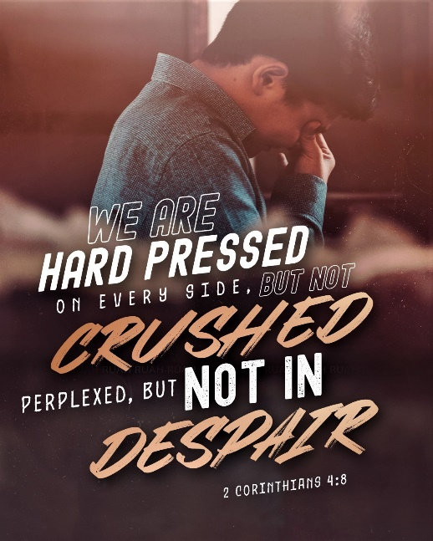
This week a dear friend lost her sister to cancer. Another friend suffered her own devastating loss. Family members and friends are still dying from Covid worldwide. Millions are dealing with emotional and spiritual darkness in what has been called our “Age of Loneliness.” And Ukrainians are losing their loved ones, their hopes and dreams for the future, and their very country as the vicious bombing and assault on Ukraine by Russia continues. The tragedies of death and darkness are pressing in around us.

But God!

- In the book of Hosea God promises that He will “make the Valley of Achor a door of hope” Hos.2:15). Achor means Trouble. He still does that for His people today.
- Because of God’s protection and power we can claim that we will not be crushed by tragedies or opposition. As Paul testified: ^{8 “}We are pressed on every side by troubles, but we are not crushed. We are perplexed, but not driven to despair. ⁹ We are hunted down, but never abandoned by God. We get knocked down, but we are not destroyed.”(2 Cor.4:8-9) Hard-pressed but not crushed.
- God has also promised never to leave us nor forsake us. He will be with us till the end of the age.(Mt. 28:20).
- Jesus took all the principalities and powers which are operating in times of death, distress, depression and doubt. He disarmed them, nailing them to the cross, and rose triumphing over them (Col.2:15). We can now live in that victory today.
- God has won life out of death, light out of darkness, strength out of weakness, hope out of despair, health out of sickness, and praise out of a spirit of heaviness.

God is the Mighty King, the King of Kings and Lord of Lords. And His Spirit in Christian believers gives us His power, and grace, and strength and faith so we can rise up over the tragedies of life that would crush us.
This is the wonderful, good news of the Christian gospel and it is the truth we need to hold onto in these days.
Biblical Examples
Scripture has been given to us to help us stay the course in these hard times and to encourage us in God’s love and care for us. Psalm 119 is entirely based on the blessings of knowing God’s Word:
Ps.119:28: My soul is weary with sorrow; strengthen me according to your word.
Ps.119:49-50: Remember your word to your servant, for you have given me hope. My comfort in my suffering is this: Your promise renews my life”
Ps.119:76-77: May your unfailing love be my comfort, according to the promise to your servant. Let your compassion come to me that I may live.
Ps.119:105-106: Your word is a lamp to my feet and a light for my path.
Ps.119:107: I have suffered much; renew my life, O Lord.

On that basis I want us to consider some Bible passages where we see God’s intervention for believers in their distress.

Knowing the suffering of people in our global fellowship, I purchased a book based on 2 Cor. 4:8, where Paul says they are pressed down but not crushed. It is called Pressed down but not Forsaken. Unfortunately, the book was self-published and suffers from repeated typographical errors and the critical lack of a publishing company copy editor. I would give it only a 2 star rating. But 3 insights in the book, from the Bible stories of the fiery furnace, the lion’s den, and the valley of the shadow, apply. In each story, God’s presence, His power and His love prevailed and brought His people through.

1.When Shadrach, Meshach and Abnego were threatened with death in the fiery furnace because they refused to bow down to the golden image of King Nebucanezzar, they told the king, “’Our God whom we serve is able to deliver us from the burning fiery furnace and will deliver us from your hand o king’,. . .The boys referred to him as O lower case k, king. After they lifted up the name of God, they belittled the name of Nebuchadnezzar. This is what we must do – declare that our King is bigger than a false king who claims a role that he cannot fill. As a child of God, you have to believe that your God can do anything…in any situation you are up against. With God all things are possible” Mt. 19:26. (Derrick Lyles, J. Pressed down but not forsaken, 2019, p25.)

2. Similarly, right before Daniel was thrown into the lion’s den for praying only to his God and not to the king, “‘Darius tells Daniel, ‘Your God, whom you serve continually, He will deliver you’ Dan.6:16 As you are entering your lions den or in the midst of it, there are men and women who are on your side, praying for you, hoping that you will come out of your situation untouched and intact.” [And it was so]. “Daniel told the king, ‘O king, live forever! My God sent his angel to shut the lions’ mouths so that they have not hurt me’. . .We can always count on God’s salvation in the midst of our den, in the face of predators. God honors his faithful servants out of love and his compassion for his creation. God will not allow you to be crushed by your circumstances” (Lyles, pp.47-48).

3. “In the book of Psalms, David, the Lord’s anointed, writes a powerful piece that speaks to the role of the Lord our God as his shepherd. . . David says to God, ‘Yea, though I walk through the valley of the shadow of death, I will fear no evil’”(pp. 51, 53). “God is always with us while we walk through the valley. The valley cannot be avoided: we must walk through the wilderness-like or deserted plains of the valley. . .The valley may be forsaken but not us. David tells us in this Psalm that God was with him the entire time. . .Often times, God does not allow us to hover over or zip through places and situations for our safety’s sake. Rushing through a valley seems ideal, [but] God will cause you to walk through the valley of death or evil, not to harm you, but to show you his might and his faithfulness in relation to the environment or the evil that is so heavily populated in the valley” (Lyles, pp. 53-55).

The confidence we have in God
The sufferings in life come in many forms. But God is greater than any tragedy we face, any obstacles put in front of us, any evil others bring against us. As the clear Scripture states: “No, in all these things we are more than conquerors through Him who loved us. . . Nothing in all creation will ever be able to separate us from the love of God that is revealed in Christ Jesus our Lord.” (Romans 8:35,39. NLT)
Bryan Jeffery Leach wrote simple chorus of faith called “The Hiding Place” based on this Romans passage. It’s very singable and good to memorize as you walk through the dark valley in your life:

In a time of trouble, in a time forlorn, there is a hiding place where hope is born.
In a time of danger, when our faith is proved, there is a hiding place where we are loved.

Refrain. There is a hiding place, a strong protective space, where God provides the grace to persevere. For nothing can remove us from the Father’s love. Tho’ all may change, yet nothing changes here.

In a time of sorrow, in a time of grief, there is a hiding place to give relief.
In a time of weakness, in a time of fear, there is a hiding place where God is near.

Refrain. There is a hiding place, a strong protective space, where God provides the grace to persevere. For nothing can remove us from the Father’s love. Tho’ all may change, yet nothing changes here.

That’s our confidence, beloved. We can be hard-pressed, but we won’t be crushed. God will sustain us, protect us, deliver us, and reveal His mighty power and love in and through us.

Thanks be to God. Amen.
Dr. Mary Lou Codman-Wilson 3 16 22
Pastor, New Hope Global Fellowship

